Alameda Aer-O-Nuts
New Years Day 2023
Fun Fly & Pot Luck Barbecue

When: Sunday, January 1, 2023 -- 9 to 2 or so. Stay for potluck lunch.

Where: Bill Osborne Field, Alameda.

Bring: Planes you like to fly and food or drinks to share.
Request: We need a barbecue grill for this one event. If you can bring one, please respond to this list or to Randy.

Activities:
Potluck Lunch about noon

Open flying on both circles.

Questions, comments, ideas, or more information please contact Randy Bush
510-325-1271, e-mail:

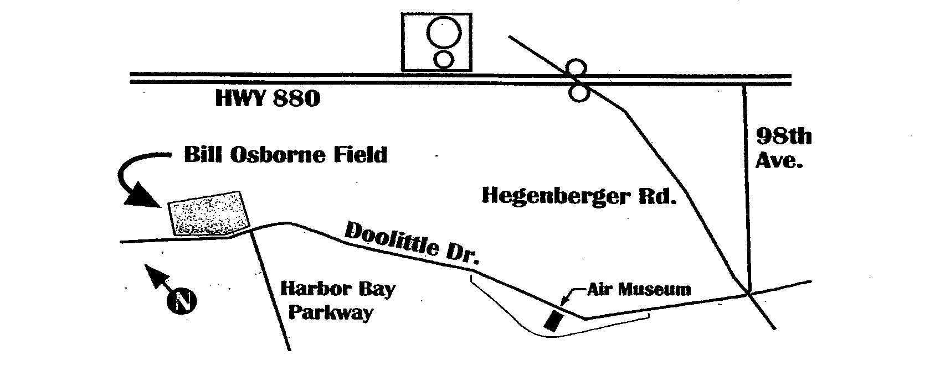
Doolittle Drive at Harbor Bay Parkway, Alameda, CA

